BASIC OF PYTHON

Python is a high-level, dynamically typed multiparadigm programming language. python code is often said to be almost like pseudocode, since it allows you to express very few lines of code while being very readable.

Before going for variable in python, let’s have a look at simple hello world program in python.

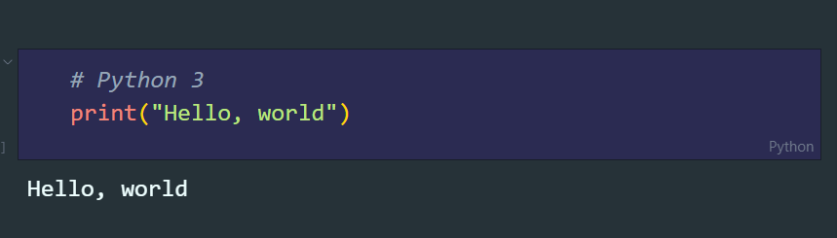

ERROR

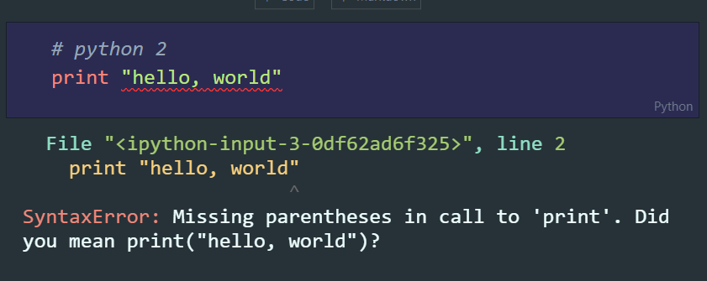

* **VARIABLE IN PYTHON**

A variable is used to store a value. According to the requirement, this value of variable may change in future.

Variable are the entities of program that hold a value.

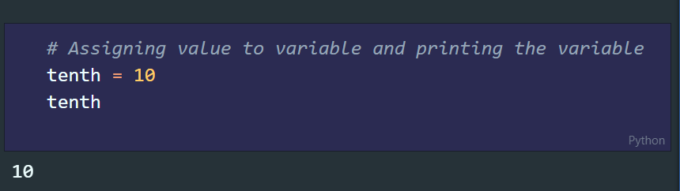

For variable -names, there are certain rules which we should follow as a best practice:-

1. Variable name can’t start with number

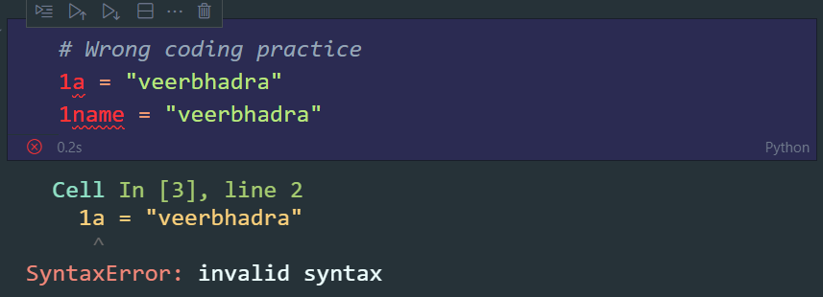

Correct way

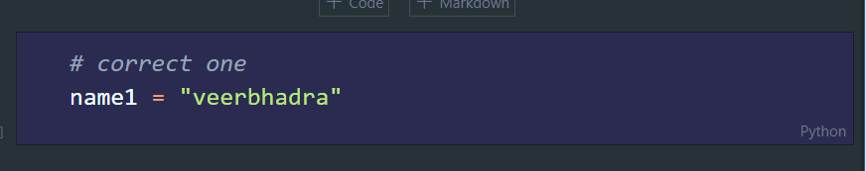

1. Variable name are case-sensitive.

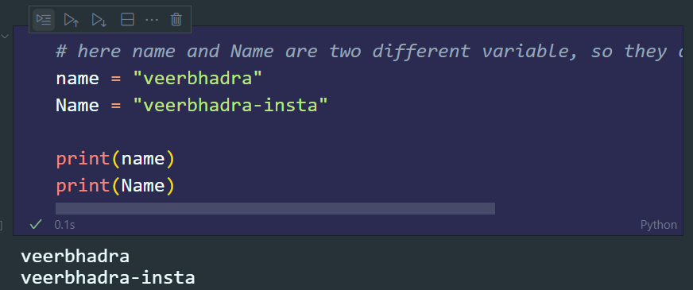

* **FUNDAMENTAL DATA-TYPES IN PYTHON**

1. INTEGERS: - Any number without a decimal point.

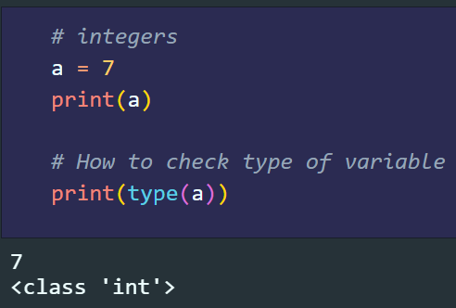

1. FLOATS: - Number with decimal point.

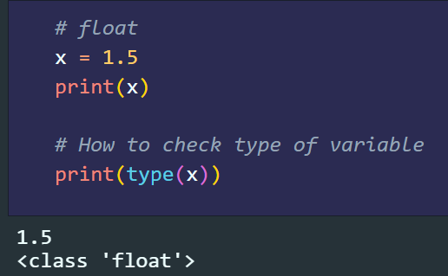

1. BOOLEAN: - It can be defined by typing True/False without quotes.

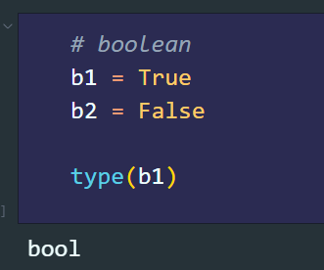

1. STRINGS: - Collection of characters(“str”).

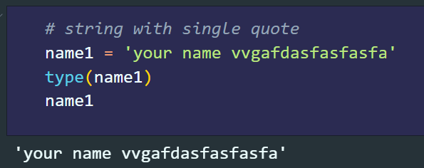

1. COMPLEX: - It can be created by using the notation X + YJ. Where x is the real component and y is the imaginary component.

